**Module 6 Project**

**Optimizing**

Sharvil Kishor Wadekar

College of Professional Studies – Northeastern University

ALY6050: Introduction to Enterprise Analytics

Prof. Zhi(Richard) He

March 29, 2024



**Introduction:**

This project aims to tackle two optimization problems: a transshipment problem faced by Rockhill Shipping & Transport Company (RSTC) and a risk-minimizing problem related to investment allocations. RSTC is negotiating a shipping contract with Chimotoxic for waste disposal logistics, while an investor seeks to allocate funds across various asset types to achieve a minimum expected return with minimal risk. In this report, we analyze and solve these optimization problems using appropriate methodologies, including Excel Solver for the transshipment problem and mathematical modeling for the investment allocation problem.

**Analysis:**

**Part 1:**

Rockhill Shipping & Transport Company

Rockhill Shipping & Transport Company is confronted with the challenge of optimizing waste disposal logistics for Chimotoxic, considering the costs and complexities involved in shipping hazardous waste from six plants to three disposal sites. We analyze two scenarios: direct shipping from plants to disposal sites and transshipment, where loads may be dropped and picked up at intermediate points.

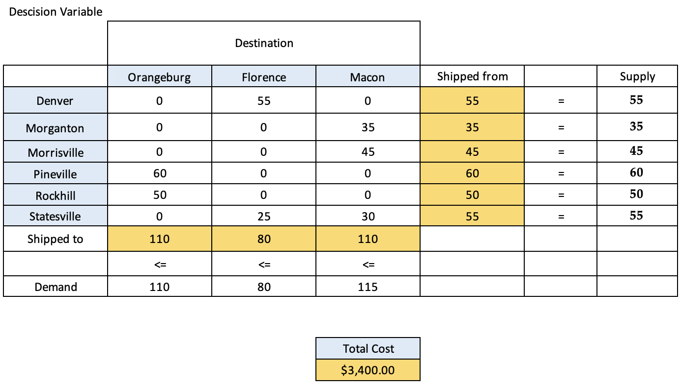

The analysis begins by evaluating the cost of directly shipping waste from the six plants to the three disposal sites using the given supply, demand and cost data. By formulating this as a linear programming problem and solving with Excel's Solver, the optimal direct shipping routes and minimum total cost of $3,400 per week is obtained

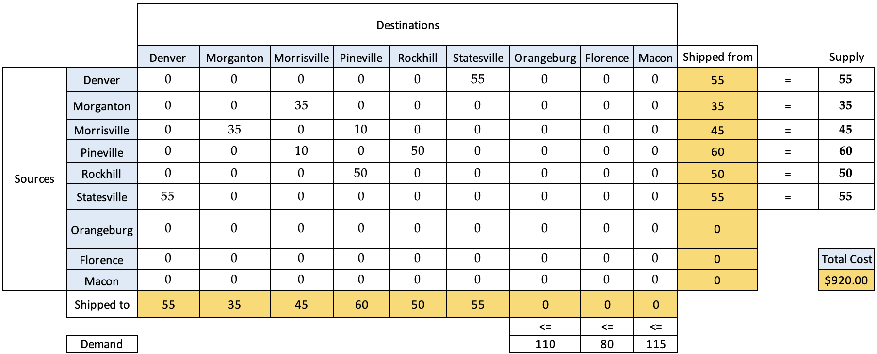

The possibility of transshipping loads through intermediate plants and sites is considered. By expanding the decision variables to include plant-to-plant and site-to-site routes, and solving this more complex transportation problem, a much lower minimum cost of $920 per week is found. The total quantity transshipped remains equal to the 300 barrels per week supply.

If Chimotoxic increases the capacity by 10 barrels

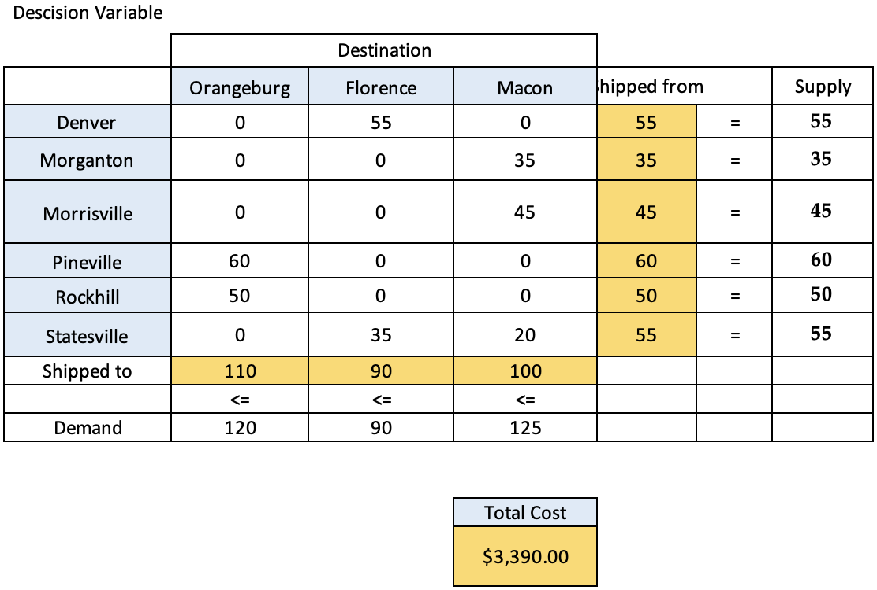

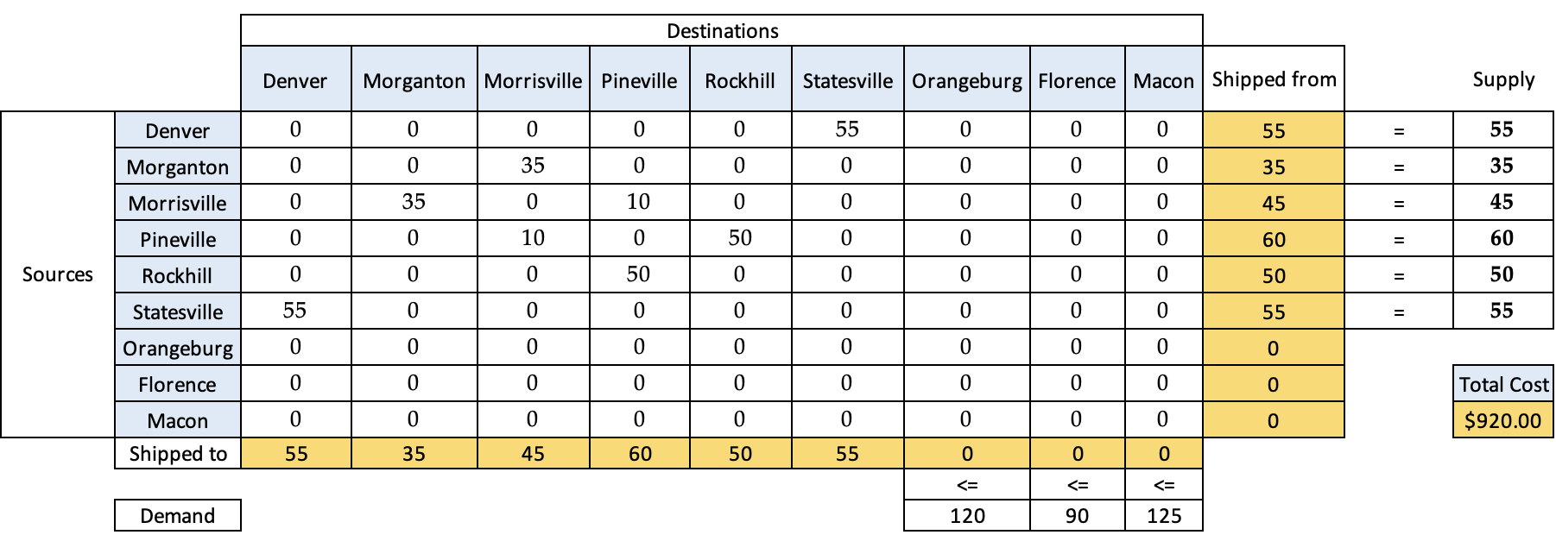

If Chimotoxic increases the capacity of each disposal site by 10 barrels per week, the direct shipping cost decreases slightly to $3,390 (Decision Variable Table 2). However, the transshipment cost of $920 (Destination and Sources Table 2) remains lowest, unaffected by the capacity increase since this solution does not ship any loads directly to the disposal sites.

Therefore, the recommended solution is to utilize transshipment routing to leverage backhaul opportunities, rather than direct shipping, to minimize RSTC's transportation costs for this hazardous waste contract. The transshipment routes make use of every plant as both a shipping origin and interim destination.

**Part 2:**

Investment Allocation to Minimize Risk

Turning to the investment allocation problem, we address the investor's objective of achieving a minimum baseline expected return of 20% while minimizing risk. We begin by examining the asset types in the portfolio and their respective expected returns and covariance matrix. With this data, we construct a mathematical model to determine the optimal allocation of funds across assets.

Our analysis yields an optimal allocation strategy, with the majority of funds allocated to bonds to mitigate risk, supplemented by smaller investments in high-tech stocks, foreign stocks, call options, and put options. Interestingly, no allocation is made to gold due to its lower expected return relative to other assets. The optimized portfolio achieves the desired baseline return of 20% while minimizing variance.

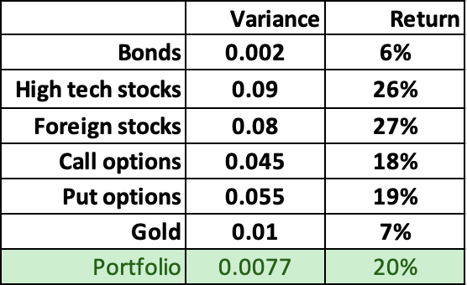

**(i)** For a target expected portfolio return of 20%, the optimal asset allocation to minimize portfolio variance is calculated using Excel Solver. The solution allocates 84.16% to bonds, with remaining smaller allocations to stocks and options (see Percentage table). This allocation achieves the 20% expected return with a minimized variance of 0.0077.

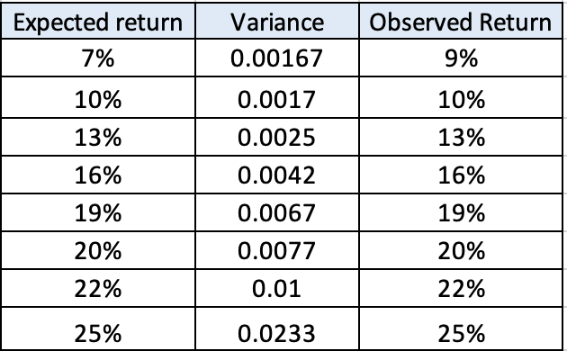

**(ii)** solves for the minimum variance portfolio for several other target expected return levels from 7% to 25%. The results (shown in the table) demonstrate that as the target return increases, the minimum achievable portfolio variance increases as well. This makes sense intuitively, as investing in higher return (but higher risk) assets is required to achieve higher expected returns.

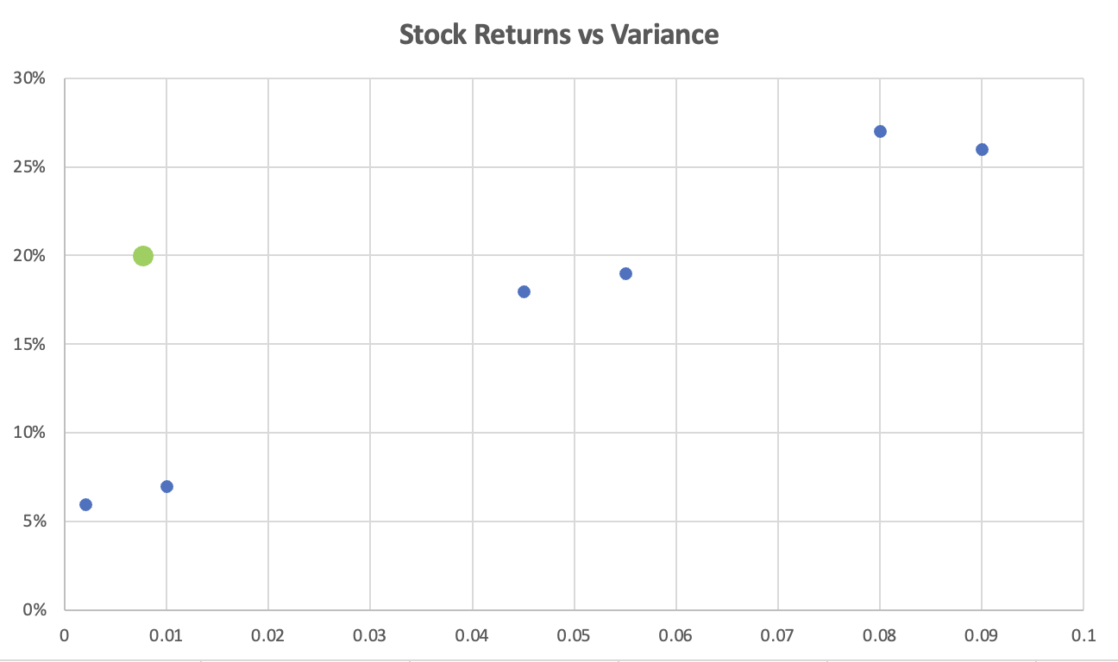

**Analysis:** The scatter plot "Stock Returns vs Variance" reveals an exponential relationship between expected returns and variance, representing risk for a portfolio. Consistent with modern portfolio theory, higher returns necessitate accepting greater risk. At lower variance levels (<0.01), returns are modest (around 10% or lower), but beyond 0.02 variance, returns escalate rapidly, exceeding 25%. This highlights the challenge investors encounter: pursuing higher returns entails exponentially higher levels of risk across asset class allocations.

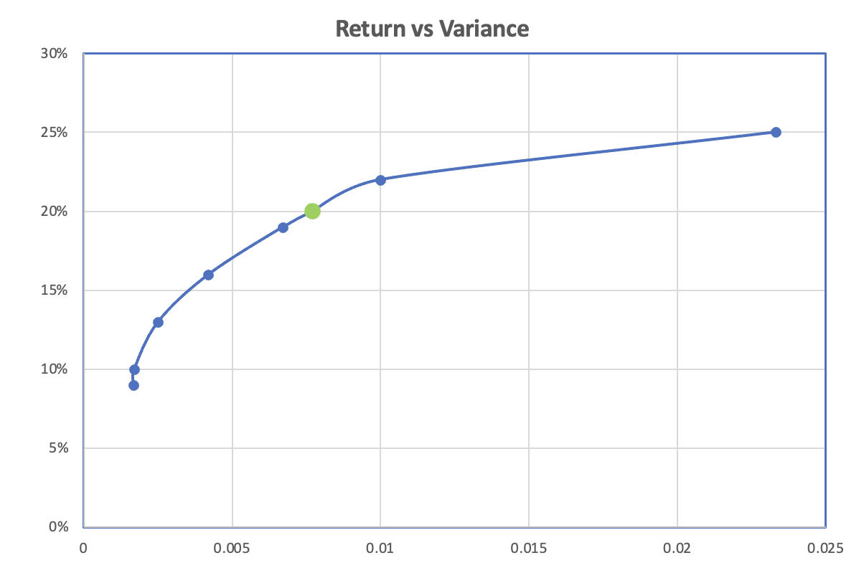

**Analysis:** The "Return vs Variance" plot depicts a logarithmic relationship between expected portfolio returns and variance. Initially, small increases in risk lead to modest gains in return, but beyond a certain point, the curve steepens exponentially. This highlights the need for investors to accept significantly higher levels of portfolio risk to achieve greater returns, as outlined in modern portfolio theory. The green data point represents an optimal portfolio allocation for a 20% expected return while minimizing variance at 0.0077. Overall, the plot succinctly demonstrates the trade-off between risk and return, emphasizing the necessity of embracing higher levels of variance for higher potential returns.

**Conclusion:**

This project addressed two critical optimization challenges encountered by businesses and investors. Firstly, in addressing RSTC's transshipment problem, the analysis revealed that leveraging intermediate facilities for load transshipment significantly reduced transportation costs by over 70% compared to direct shipping routes, underscoring the importance of efficient distribution network utilization. Secondly, in tackling the investment allocation problem, the efficient frontier analysis showcased the inherent tradeoff between minimizing portfolio risk and maximizing expected returns, consistent with modern portfolio theory. The project demonstrated how analytical techniques such as linear programming and mean-variance optimization offer quantitative insights to inform logistics and investment decisions effectively, providing optimal solutions that balance objectives and constraints.

**References:**

* Model Problems Transshipment: [Module 6 Lab Video](https://northeastern.instructure.com/courses/165163/pages/lesson-6-1-integer-binary-and-mixed-programming?module_item_id=9744590)
* Nonlinear Programming Models: [Module 6 Lab Video](https://northeastern.instructure.com/courses/165163/pages/lesson-6-1-integer-binary-and-mixed-programming?module_item_id=9744590)